**PRN NO: 20UET301**

**BATCH NO: TY 5**

**TIC-TAC-TOE GAME USING PYTHON**

* **Description**

There will be two players in a game. Two signs represent each player. The general signs used in the game are **X** and **O**. Finally, there will be a board with **9** boxes.

See the tic-tac-toe board visually.

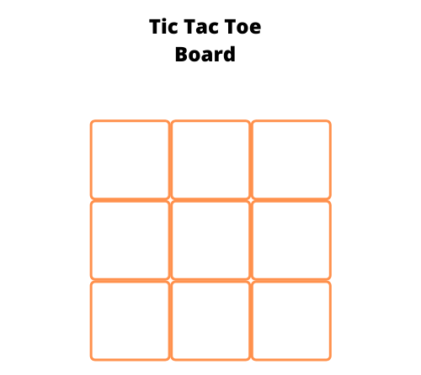

The gameplay will be as follows.

* First, one user will place their sign in one of the available empty boxes.
* Next, the second user will place their sign in one of the available empty boxes.
* The goal of the players is to place their respective signs completely row-wise or column-wise, or diagonally.
* The game goes on until a player wins the game or it ended up in a draw by filling all boxes without a winning match.